COAL LAB 04
22F - 3441
BSCS - 3D
CODE 1:
org 0x100

jmp start ;

num : db 2002

strat :
mov ax , [num]
shl al , 4
shl ah , 4

mov ax , 04c00
int 0x21
OUTPUT:
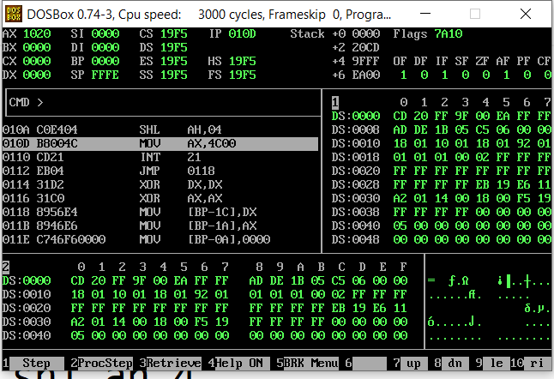
CODE 2:
org 0x0100

mov ax,5
mov bx,ax
shl ax,1
add ax,bx

mov ax,0x4c00
int 0x21
OUTPUT:
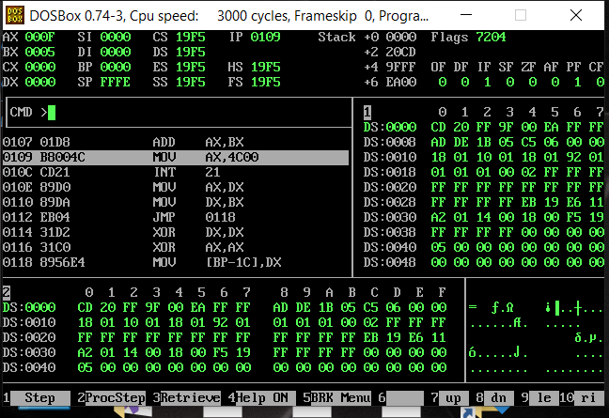
CODE 3:
org0x100
; Multiply AX by itself (AX * AX)
mov ax,5
imul ax, ax

; AX now contains the square of the original number
mov ax , 0x4c00
int 0x21
OUTPUT:
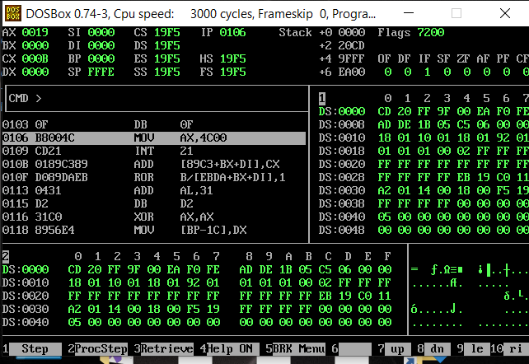
CODE 4:
org 0x0100
mov ax,4
shr ax,1
mov ax,0x4c00
int 0x21
OUTPUT:
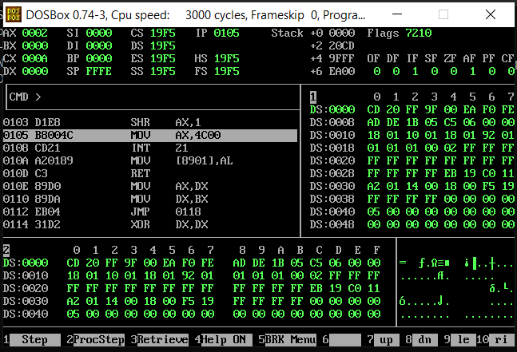
CODE 5:
org 0x100
jmp start
num:dw 3A45
start:
mov ax,[num]
rol al,4
ror ah,4
mov bh,al
mov al,ah
mov ah,bh
mov ah,0x4c00
int 0x21
OUTPUT:
